Le Yu

MCEN 5055

Aug. 31th, 2018

Bad Design Description

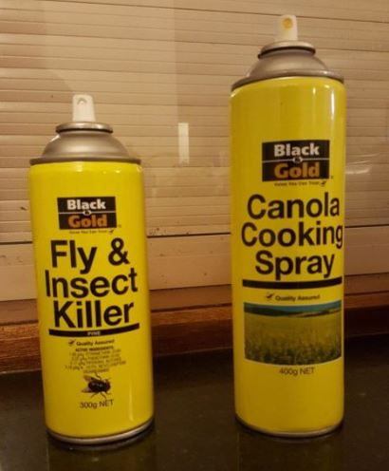 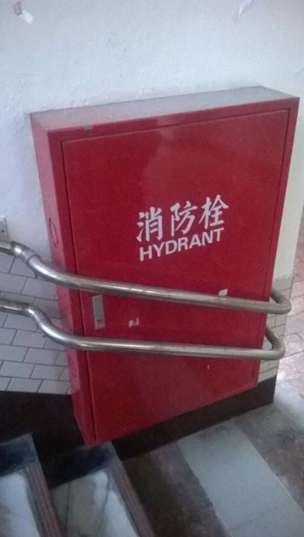

Figure 1 Figure 2

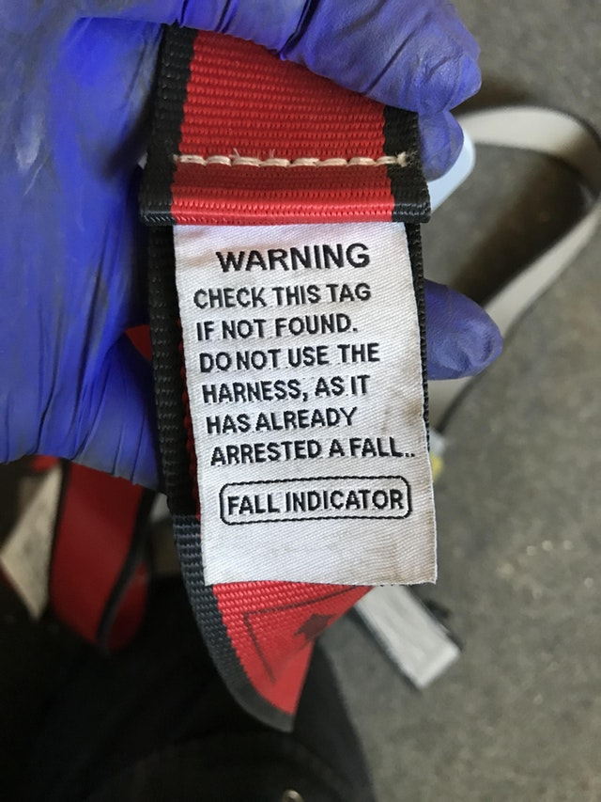

Figure 3

The pictures above are three bad design that I found from online source. The Three designs are bad due to different reasons, as I will analyze below.

The design in figure 1 is a failure because the painting of the two cans are very likely, while the functions of the two sprays are completely different and should not be misused. One of the sprays is used for killing household insects and the other one is for cooking purpose. The likeliness of two sprays could easily cause users misuse one of it as another. In the case of trying to kill insects using the cooking spray, the worst scenario is that the user couldn’t kill it and need to clean the canola oil. But in the other case that user uses the insect killer spray for cooking, such using could cause serious health threat to the people who eat the food.

Figure 2 shows a failure design of a cannot-open fire hose case. The purpose of such design is trying to install a fire hose box and handrail simultaneously at the side of a stair. But in case of a fire, the door of this fire hose cannot be opened and cannot function as a fire-fighting unit in the building. As a result, such design only satisfies one out of two design purpose. A better design could be having the fire hose box upper on the wall, so that the handrail will not block its door.

The warning tag design in figure 3 is a bad design. The purpose of such warning tag is to warn the user this cable is no longer safe to use when a joint is broken. But at the time when the joint broken, this warning tag will be no longer attached to the cable, so that the user is likely to not notice such change on the cable and keep using it until some accident happens. A better design could be the following one: the tag will be fixed on the cable at two points, one is the original points that will break when the cable is not safe, and another will never break and keeps tag attached to the cable all the time. Thus, by the time when one joint is broken, the user will immediately notice and avoid accident happens.

The three bad designs are all have distinct purpose when designing them. But the problem arises from lack of validation of design and re-design.